Software Requirement Specification

Diabetes Care

By

**Jirayu Chinpongsuwan 552115011**

Department of Software Engineering

College of Arts, Media and Technology

Chiang Mai University

_________________________________________________

**Project Advisor**

Dr. Prompong Sugunnasil

**Document History**

|  |  |  |  |  |  |  |  |  |
| --- | --- | --- | --- | --- | --- | --- | --- | --- |
| **Document Name** | **Version** | **Status** | **Date** | | **Viewable** | | **Reviewer** | **Responsible** |
| Document |  | | | | | | | |
| diabetes -SRS-V.0.1.docx | Add: Chapter One Introduction  Add: Chapter Two Overall Description & Requirement  Add: Chapter Three Function requirement  Add: Chapter Four Specification Requirement | Draft | | February  29, 2016 | | JC, PS | JC, PS | JC, PS |
| diabetes -SRS-V.0.1.docx | Update: Chapter Three Function requirement  Update: Chapter Four Specification Requirement | Draft | | April 25,2016 | | JC, PS | JC, PS | JC, PS |
| diabetes -SRS-V.0.1.docx | Update: Chapter Three Function requirement | Draft | | July  1,2016 | | JC, PS | JC, PS | JC, PS |
| diabetes -SRS-V.0.2.docx | Update: Chapter Three Function requirement  Update: Chapter Four Specification Requirement | Draft | | July  10,2016 | | JC, PS | JC, PS | JC, PS |
| diabetes -SRS-V.0.2.docx | Update: Chapter Four Specification Requirement | Draft | | July  14,2016 | | JC, PS | JC, PS | JC, PS |
| diabetes -SRS-V.0.2.docx | Update: Chapter Four Specification Requirement | Release | | November  03,2016 | | JC, PS | JC, PS | JC, PS |

*PS: Dr. Prompong Sugunnasil

*JC: Mr. Jirayu Chinpongsuwan

**Table of Contents**

Chapter One | Introduction 6

1.1 Objecttive 6

1.2 Intended Audience and Reading Suggestions 6

1.3 Project Scope 6

1.4 Acronyms and Difinitions 7

Chapter Two | Overall Description & Requirement 8

2.1 Product Perspective 8

2.2 Product Feature 8

2.3 User Characteristics 8

2.4 Development Environment 8

Chapter Three | Function Requirement 8

3.1 User Requirement Specification 8

Feature#1 Authentication system. 9

Feature#2 Account management. 9

Feature#3 Nutrition management. 9

Feature#4 Activity management. 9

Feature#5 Activity plan and recommend system. 9

Feature#6 Nutrition plan system. 9

Feature#7 Health monitors system. 9

Feature#8 Behavior monitor system. 10

3.2 User Requirement Specification and Software Requirement 10

Feature#1 Authentication system. 10

Feature#2 Account management. 10

Feature#3 Nutrition management. 13

Feature#4 Activity management. 14

Feature#5 Activity plan and recommend system. 15

Feature#6 Nutrition plan system. 15

Feature#7 Health monitors system. 15

Feature#8 Behavior monitor system. 16

Chapter Four | Specification Requirement 21

4.1 Use Case Diagram 21

3.4.1.1 The Overview Use Case Diagram of the System 21

3.4.1.2 Use Case Name 22

4.2 Use Case Description and Activity Diagram 27

UC-01 27

UC-02 29

UC-03 31

UC-04 35

UC-05 37

UC-06 39

UC-07 42

UC-08 45

UC-09 47

UC-10 49

UC-11 51

UC-12 53

UC-13 55

UC-14 57

UC-15 59

UC-16 61

UC-17 63

UC-18 65

UC-19 67

UC-20 69

UC-21 71

UC-22 73

UC-23 75

UC-24 77

UC-25 79

UC-26 81

UC-27 73

UC-28 75

UC-29 87

UC-30 89

**Chapter One | Introduction**

* 1. **Objective**

The objective of the Software Requirement Specification document is out line overall requirement of “Diabetes Web application” project. This document has described clearly and accurately descriptively. About detail in Software Requirement Specification is included by function, performance, design consistency, and external interface. This document is based on the project proposal and project plan. It also constraint the general description of user type who is involved with the system.

The Software Requirement Specification document is also a guideline of design the “Diabetes Web application” system

* 1. **Intended Audience and Reading Suggestions**

This Software Requirement Specification is created for everyone who is involved with this “Diabetes web application” project. It will make convenience for those people as follow

**1.2.1 Development Team**

**-** To help the developer understand the requirement and plan how to work together.

**1.2.2 Customer**

**-** Help the customer to know the basic requirement of the “Diabetes Web application”

**1.3 Project Scope**

The main feature of “Diabetes Web application” are as follows:

* Authentication system.
* Account management.
* Nutritionists management.
* Admin management nutritionists.
* Health plan system.
* Statistics glycemic.
* Analyze diabetes.

**1.4 Acronyms and Definitions**

**1.4.1 Acronyms**

SRS: Software Requirement Specification

URS: User Requirement Specification

UC: Use Case

AD: Activity Diagram

**1.4.2 Definitions**

**Feature** Transformation of input parameters to output parameters based on a specified algorithm. It describes the functionality of a product in the language of the product. Used for requirements analysis, design, coding, testing or maintenance.

**User Interface** User interface (UI) is everything designed into an information device with which a human being may interact including display screen, keyboard, mouse, light pen, the appearance of a desktop, illuminated characters, help messages, and how an application program or a Web site invites interaction and responds to it. [1]

**UML** The Unified Modeling Language (UML) is a general -purpose modeling language in the field of software engineering, which is designed to provide a standard way to visualize the design of a system. [2]

**Activity Diagram** Activity diagrams are graphical representations of the workflows of stepwise activities and actions with support for choice, iteration and concurrency. Activity diagrams show the overall flow of control. [3]

**Use Case** A use case is a methodology used in system analysis to identify, clarify, and organize system requirements. The use case is made up of a set of possible sequences of interactions between systems and users in a particular environment and related to a particular goal. It consists of a group of elements (for example, classes and interfaces) that can be used together in a way that will have an effect larger than the sum of the separate elements combined. [4]

**Use Case Diagram** A use case diagram at its simplest is a representation of a user’s interaction with the system and depicting the specifications of a use case. A use case diagram can portray the different types of users of a system and the various ways that they interact with the system. [5]

**Chapter Two | Overall Description**

**2.1 Product Perspective**

“Diabetes Care Web application” is web application to help customer to take care the diabetic. Customer will be convenient to protect complication from diabetes. This system will help customer to be more convenient to organize because the customer will get info to be analyzed from system. In term of visitor, they can search for the information and detail about diabetes. This system will be much more helpful for patient diabetes.

**2.2 Product Feature**

Diabetes project has separated the whole project to one processors. The description is shown below:

Progress I: Feature#1: Authentication system.

Feature#2: Account management.

Feature#3: Nutritionists management.

Feature#4: Activity management.

Feature#5: Activity plan and recommend system.

Feature#6: Nutrition plan system.

Feature#7: Health monitors system.

Feature#8: Behavior monitors system.

**2.3 User Characteristics**

User: User can direct access an application via their desktop, tablets, and phones to every part of this application by requesting internet connection. The patient is the person who can create a health plan and monitor nutrition behavior for preventing theirs from the complications disease. Admin is the person who can manage the account of doctor, nurse, and nutritionists. Doctor/Nurse is the person who can enter patient information into the system and management the activity in a part of insert/update/delete. And the nutritionist is the person who can control the nutrition in part of insert/update/delete.

**2.4 Development Environment**

Laptops

- DELL

Processor: Intel(R) Core(TM) i5-6200U CPU @ 2.30GHz 2.14 GHz

Memory: 4.00 GB (3.90 GB usable)

System type: window 10 64-bit Operating System.x64-based processor

**Chapter Three | Functional Requirement**

**3.1 User Requirement Specification**

**Feature#1: Authentication system.**

URS-01: The patient, doctor, nurse and admin can login to a web application by using username and password.

URS-02: The patient, doctor, nurse and admin can log out from a web application.

**Feature#2: Account management.**

URS-03: The doctor and nurse can enter patient information (username, password, confirm password, first name, last name, age, gender, weight, height, address, city, zip code, diabetes type and date that start treatment) to the database server on a web application.

URS-04: The doctor and nurse can access to patient information (first name, last name, age, gender, weight, height, diabetes type, blood sugar value, and start treatment).

URS-05: The patient can view information include first name, last name, age, gender, weight, height, address, city, zip code, medicine, diabetes type, blood sugar value, and start treatment on profile page.

URS-06: The patient can edit information include first name, last name, age, gender, diabetes type, weight, and height on profile page.

URS-07: The patient can change the password for login.

URS-08: The admin can add nurse, doctor, and nutritionists account to the system on administrator page.

URS-09: The admin can edit nurse, doctor, and nutritionists account on administrator page.

URS-10: The admin can delete nurse, doctor, and nutritionists account from the system on administrator page.

**Feature#3: Nutrition management.**

URS-11: The nutritionists can add food information (food name, food calories and food glycemic index) to the system on nutrition management page.

URS-12: The nutritionists can edit food information (food name, food calories and food glycemic index) on nutrition management page.

URS-13: The nutritionists can delete food information (food name, food calories and food glycemic index) from the system on nutrition management page.

**Feature#4: Activity management**

URS-14: The nurse and doctor can add the exercise recommend (symptom, suggestion, proper exercise, exercise inappropriate, and step exercise) to the system on exercise management page.

URS-15: The nurse and doctor can edit the exercise recommend (symptom, suggestion, proper exercise, exercise inappropriate, and step exercise) on exercise management page.

URS-16: The nurse and doctor can delete the exercise recommend from the system on exercise management page.

**Feature#5: Activity plan and recommend system**.

URS-17: The patient t can select the symptoms on health plan page.

URS-18: The patient can get the suggestion about exercise which include (symptom, suggestion, proper exercise, exercise inappropriate, and step exercise) from the system.

**Feature#6: Nutrition plan system.**

URS-19: The patient can add food from the database to record in a health plan.

URS-20: The patient can view the total of glycemic index and calorie of food that selected in health plan.

URS-21: The patient can delete a food from the health plan.

**Feature#7: Health monitors system.**

URS-22: The patient can record blood sugar value to the database.

URS-23: The patient can view body mass index.

### URS-24: The patient can view [basal metabolic rate](http://kcal.memo8.com/bmr/).

URS-25: The patient can view the statistic line graph (x = blood sugar value, y = date) of blood sugar.

URS-26: The patient can view interpretation about blood sugar level from the system.

**Feature#8: Behavior monitors system.**

URS-27: The patient can select food name from the database.

URS-28: The patient can check the list of medicine.

URS-29: The patient can get analyze of nutrition behavior as image (E:\Diabetes\Diabetes1\Diabetes1\img\smile.png ,E:\Diabetes\Diabetes1\Diabetes1\img\beware.png, E:\Diabetes\Diabetes1\Diabetes1\img\danger.png).

URS-30: The patient can view the daily graph of the glycemic level.

**3.2 User Requirement specification and Software Requirement Specification**

**Feature#1: Authentication system.**

**URS-01: The patient, doctor, nurse and admin can login to a web application by using username and password.**

**Requirement**

SRS-01: The system shall provide the login UI to receive username and password.

SRS-02: The system shall provide button “login”.

SRS-03: The system shall verify username and password with the database.

SRS-04: The system shall display error message “Invalid login attempt”, when user input username and password that not exist on the database.

SRS-03: The system shall validate field username and password.

SRS-05: The system shall display error message “The UserName field is required”, when the user does not input username.

SRS-06: The system shall display error message “The Password field is required”, when the user does not input password.

SRS-07: The system shall redirect to behavior page, when the patient login to the web application success.

SRS-08: The system shall redirect to index page and display nurse/doctor bar, when the doctor or nurse login to the web application.

SRS-09: The system shall redirect to index page and display nutritionists bar, when the nutritionists login to the web application.

SRS-10: The system shall redirect to index page and display admin bar, when admin login to the web application

**URS-02: The patient, doctor, nurse and admin can log out from a web application.**

**Requirement**

SRS-11: The system shall provide button “Log out”.

SRS-12: The system shall destroy session, when user click log out button.

SRS-12: The system shall redirect to home page, when user log out success.

**Feature#2: Account management.**

**URS-03: The doctor and nurse can enter patient information (username, password, confirm password, first name, last name, age, gender, weight, height, address, city, zip code, diabetes type and date that start treatment) to the database server on a web application.**

**Requirement**

SRS-13: The system provides the register UI which includes input fields to input username, password, confirm password, first name, last name, age, gender, weight, height, address, city, zip code, diabetes type and date that start treatment

SRS-14: The system shall provide button “Submit”.

SRS-17: The system shall verify email and provide error message “the email is already taken”, when the user input email is already in the database.

SRS-18: The system shall validate email and provide error message “the email is invalid”, when user input wrong format e-mail.

SRS-19: The system shall verify username and provide error message “the Username is already taken”, when the user input username is already in the database.

SRS-20: The system shall validate username and provide error message “the Username field is required”, when the user does not input username.

SRS-21: The system shall validate password and provide error message “the Password field is required”, when the user does not input password.

SRS-22: The system shall validate password and provide error message “The password must be at least 6 characters long”, when the user input password less than 6 characters.

SRS-23: The system shall validate confirm password and provide error message “the confirm password field is required”

SRS-23: The system shall validate confirm password and provide error message “the confirm password and password does not match.

SRS-24: The system shall validate first name and provide error message “the First Name field is required”, when the user does not input the first name.

SRS-25: The system shall validate last name and provide error message “the Last Name field is required”, when user does not input the last name.

SRS-26: The system shall provide two select options male and female in the select box gender of the user.

SRS-27: The system shall validate age and provide error message “the Age field is required”, when the user does not input age.

SRS-28: The system shall validate age and provide error message “age is must be a number”, when user input wrong format age.

SRS-29: The system shall validate address and provide error message the “Address field is required”, when the user does not input address.

SRS-30: The system shall provide two select options diabetes type 1 and diabetes type 2 in the select box diabetes type of user.

SRS-31: The system shall validate height and provide error message “height must be a number”, when user input wrong format height.

SRS-32: The system shall validate height and provide error message the “Height field is required”, when the user does not input height.

SRS-33: The system shall validate weight and provide error message “weight must be a number”, when user wrong input format weight.

SRS-34: The system shall validate weight and provide error message the “Weight field is required”, when the user does not input weight.

SRS-35: The system shall provide error message the “Start Treatment field” is required. When the user does not input, start treatment.

SRS-36: The system shall save user information to database, when nurse or doctor information success.

SRS-37: The system shall redirect to home page, when nurse or doctor registration is a success.

**URS-04: The doctor and nurse can access to patient information (first name, last name, age, gender, weight, height, diabetes type, blood sugar value, and start treatment).**

**Requirement**

SRS-39: The system shall provide a search field.

SRS-40: The system shall provide a search button.

SRS-42: The system shall validate search field.

SRS-43: The system shall display error message “Please input patient name”, when the doctor or nurse not input name of patient on search field.

SRS-40: The system shall search for the patient based on first name from the database.

SRS-41: The system shall display list of patients as a table providing first name, last name, age, gender, weight, height, diabetes type, blood sugar value, and start treatment, when finish SRS-40.

SRS-42: The system shall display error message “___”, when the system can’t find the patient name in the database.

**URS-05: The patient can view information include first name, last name, age, gender, weight, height, address, medicine, diabetes type, blood sugar value, and start treatment on profile page.**

**Requirement**

SRS-45: The system shall provide UI label which include first name, last name, age, gender, weight, height, address, medicine, diabetes type, blood sugar value, and start treatment

SRS-46: The system shall receive the information of current patient which include first name, last name, age, gender, weight, height, address, medicine, diabetes type, blood sugar value, and start treatment from the database.

SRS-47: The system shall display label which include first name, last name, age, gender, weight, height, address, medicine, diabetes type, blood sugar value, and start treatment on profile page.

**URS-06: The patient can edit information include first name, last name, age, gender, diabetes type, weight, and height on profile page.**

**Requirement**

SRS-48: The system shall provide UI, which includes input fields to input first name, last name, and select box to choose gender, age, select box to select diabetes type, height, weight, and start treatment for edit patient info.

SRS-14: The system shall provide button “Submit”.

SRS-50: The system shall validate input field first name, last name, a select box to choose gender, age, select box to select diabetes type, height, weight, and start treatment.

SRS-51: The system shall display error message “The field Height must be a number.”, when user input wrong format height.

SRS-52: The system shall display error message “The field Weight must be a number.”, when user wrong input format weight.

SRS-51: The system shall display error message “The Age field is required.”, when the user does not input age.

SRS-52: The system shall display error message “The Weight field is required.”, when the user does not input weight.

SRS-51: The system shall verify height and provide error message “The Height field is required.”, when the user does not input height.

SRS-53: The system shall save change the information which include field first name, last name, a select box to choose gender, age, select box to select diabetes type, height, weight, and start treatment in the database.

SRS-49: The system shall redirect to a profile page, when patient edit information success.

**URS-07: The patient can change the password for login.**

**Requirement**

SRS-54: The system shall provide input fields which include current password, new password, and confirm the password.

SRS-14: The system shall provide button “Change password”.

SRS-55: The system shall verify the input field current password, new password, and confirm the password.

SRS-56: The system shall verify current password and provide error message “Incorrect password”, when the patient input current password that not match the password on the database.

SRS-57: The system shall verify new password and provide error message “The New password field is required”, when the patient not input new password.

SRS-55: The system shall validate the input field current password, new password, and confirm the password.

SRS-58: The system shall validate new password and provide error message “The New password must be at least 6 characters long”, when the patient input new password less than 6 characters.

SRS-59: The system shall validate confirm password and provide error message “new password and confirm password does not match”, when the patient input a new password and confirm password does not match.

SRS-55: The system shall save change new password on the database, when user change password success.

SRS-60: The system shall redirect to the profile page, when user change password success.

**URS-08: The admin can add nurse, doctor, and nutritionists account to the system on administrator page.**

**Requirement**

SRS-61: The system shall provide UI to create new account include input fields to input username, password, email, and selection box to select the role of the user.

SRS-62: The system shall provide three select options doctor, nurse, and nutritionists in the select role of the user.

SRS-14: The system shall provide “Submit” button.

SRS-63: The system shall validate input field username, password, and e-mail.

SRS-65: The system shall display error message “the e-mail is invalid”, when the admin input email wrong format.

SRS-63: The system shall verify input field username, password, and e-mail with database.

SRS-64: The system shall display error message the “email is already taken”, when the admin input email is already in the database.

SRS-66: The system shall verify username error message “the username is already taken”, when the admin input username is already in the database.

SRS-67: The system shall verify username and display error message the “username field is required”, when the admin does not input username.

SRS-67: The system shall verify password and display error message the “password field is required”, when the admin does not input username.

SRS-67: The system shall verify email and display error message the “email field is required”, when the admin does not input username.

SRS-68: The system shall save data in the database, when admin click button “Submit”.

SRS-69: The system shall redirect to the home page of account management, when admin creates new account success.

**URS-09: The admin can edit nurse, doctor, and nutritionists account on administrator page.**

**Requirement**

SRS-70: The system shall provide UI to edit account include input fields to input email, password, and selection box to select the role of the user.

SRS-71: The system shall provide three select options doctor, nurse, and nutritionists in the select role of the user.

SRS-14: The system shall provide “Submit” button.

SRS-72: The system shall validate input field email and password.

SRS-64: The system shall display error message “the email is already in the database”, when the admin input email is already in the database.

SRS-65: The system shall display error message “the email is invalid”, when user input wrong format e-mail.

SRS-73: The system shall provide error message “The password must be at least 6 characters long”, when the admin input new password less than 6 characters.

SRS-74: The system shall redirect to account management page, when the admin finish edit user account.

**URS-10: The admin can delete nurse, doctor, and nutritionists account from the system on administrator page.**

**Requirement**

SRS-75: The system shall provideUI label list of user account.

SRS-75: The system shall providedelete button.

SRS-76: The system shall provide confirm message, when the admin click delete button

SRS-76: The system shall remove user account from the table “AspUser” on the database.

SRS-77: The system shall redirect to account management page, when the admin delete account success.

**Feature#3: Nutrition management.**

**URS-11: The nutritionists can add food information (food name, food calories and food glycemic index) to the system on nutrition management page.**

**Requirement**

SRS-78: The system shall provide UI to create new foods which include input field to input food name, glycemic index, and calorie.

SRS-79: The system shall provide “create” button

SRS-80: The system shall validate input field food name, glycemic index, and calorie.

SRS-81: The system shall display error message “The glycemic index must be a number”, when the nutritionists input character on glycemic index field.

SRS-82: The system shall display error message “The calorie must be a number”, when the nutritionists not input calorie.

SRS-83: The system shall display error message “The glycemic index field is request”, when the nutritionists input character on glycemic index field.

SRS-84: The system shall display error message “The calorie field is request”, when the nutritionists not input calorie.

SRS-85: The system shall save data of food name, food glycemic and food calories to the table “Foods” on the database, when nutritionists click button “Create”.

SRS-86: The system shall redirect to nutrition management page, when the nutritionists create new foods success.

**URS-12: The nutritionists can edit food information (food name, food calories and food glycemic index) on nutrition management page.**

**Requirement**

SRS-87: The system shall provide UI to edit include input field to input food name, glycemic index, and calorie.

SRS-88: The system shall provide “save” button

SRS-89: The system shall validate input field food name, glycemic index, and calorie.

SRS-81: The system shall display error message “The glycemic index must be a number”, when the nutritionists input character on glycemic index field.

SRS-82: The system shall display error message “The calorie must be a number”, when the nutritionists not input calorie.

SRS-83: The system shall display error message “The glycemic index field is request”, when the nutritionists input character on glycemic index field.

SRS-84: The system shall display error message “The calorie field is request”, when the nutritionists not input calorie.

SRS-90: The system shall save change the data of food name, food glycemic, food calorie in the table “Foods” on the database, when nutritionists click button “Save”.

SRS-91: The system shall redirect to nutrition management page, when the nutritionists edit foods success.

**URS-13: The nutritionists can delete food information (food name, food calories and food glycemic index) from the system on nutrition management page.**

**Requirement**

SRS-75: The system shall provide UI label list of food to the nutritionists.

SRS-75: The system shall providedelete button.

SRS-92: The system shall provide confirm page, when the nutritionists click delete button.

SRS-76: The system shall remove food from the table “Foods” on the database.

SRS-93: The system shall redirect to nutrition management page, when the nutritionists confirm to delete account.

**Feature#4: Activity management**

**URS-14: The nurse and doctor can add the exercise recommend (symptom, suggestion, proper exercise, exercise inappropriate, and step exercise) to the system on exercise management page.**

**Requirement**

SRS-94: The system shall provide UI to create the new activity which includes input field symptom, suggestion, proper exercise, exercise inappropriate, and step exercise.

SRS-79: The system shall provide “create” button

SRS-95: The system shall save data of symptom, suggestion, proper exercise, exercise inappropriate, and step exercise to the table “Exercises” on the database.

SRS-96: The system shall redirect to exercise management page, when the doctor or nurse finish creates new exercise.

**URS-15: The nurse and doctor can edit the exercise recommend (symptom, suggestion, proper exercise, exercise inappropriate, and step exercise) on exercise management page.**

**Requirement**

SRS-97: The system shall provide UI to edit the data include input field symptom, suggestion, proper exercise, exercise inappropriate, and step exercise.

SRS-88: The system shall provide “save” button.

SRS-98: The system shall save change data of symptom, suggestion, proper exercise, exercise inappropriate, and step exercise in the table “Exercises” on the database.

SRS-96: The system shall redirect to exercise management page, when the doctor or nurse creates new exercise success.

**URS-16: The nurse and doctor can delete the exercise recommend from the system on exercise management page.**

**Requirement**

SRS-75: The system shall provide UI label list of exercises to nurse or doctor.

SRS-75: The system shall providedelete button.

SRS-97: The system shall provide confirm page, when nurse or doctor click delete button.

SRS-76: The system shall remove exercise from the table “Exercises” on the database.

SRS-98: The system shall redirect to exercise management page, when the doctor or nurse confirm to delete account.

**Feature#5: Activity plan and recommend system.**

**URS-17: The patient can select the symptoms on health plan page.**

**Requirement**

SRS-99: The system shall retrieve of all symptoms from the database.

SRS-99: The system shall provide a dropdown list displaying a list of symptoms.

SRS-101: The system shall provide “select” button.

SRS-103: The system shall display detail of symptoms, when select symptoms success.

**URS-18: The patient can get the suggestion about exercise which include (symptom, suggestion, proper exercise, exercise inappropriate, and step exercise) from the system.**

**Requirement**

SRS-101: The system must finish on URS-17

SRS-102: The system shall display detail table of exercise which includes symptom detail, exercise appropriate, exercise inappropriate, and steps of exercise, when patient select the symptoms success.

**Feature#6: Nutrition plan system.**

**URS-19: The patient can select food from the database to record in a health plan.**

**Requirement**

SRS-104: The system shall retrieve of all food names from the database.

SRS-103: The system shall provide a dropdown list displaying a list of food name.

SRS-105: The system shall provide “Add” button.

SRS-106: The system shall record the selected food into the database.

SRS-107: The system shall display list of food including food name, food glycemic, and food calories, when success process.

**URS-20: The patient can view the total of glycemic index and calorie of food that selected on health plan.**

**Requirement**

SRS-108: The system shall provide UI label to display the average value of glycemic index and calories of food.

SRS-108: The system shall get the data of glycemic index and calories of food from the database.

SRS-108: The system shall calculate the value of glycemic index and calories.

SRS-108: The system shall display the average value of glycemic index of food that selected on health plan.

SRS-109: The system shall display the average value of calorie of food that selected on health plan.

**URS-21: The patient can delete a food from the health plan.**

**Requirement**

SRS-75: The system shall provide label list of food name to the patient.

SRS-75: The system shall providedelete button.

SRS-110: The system shall delete a food from the database, when the patient click delete button.

**Feature#7: Health monitors system.**

**URS-22: The patient can record blood sugar value to the database.**

**Requirement**

SRS-112: The system shall provide input field to input blood sugar.

SRS-113: The system shall provide button “add”.

SRS-114: The system shall record the value to table “Glycemic” on the database.

SRS-115: The system shall validate input field blood sugar.

SRS-116: The system shall display error message “blood sugar must be a number”, when the patient input character.

SRS-117: The system shall display error message “blood sugar cannot be negative”, when the user input blood sugar minus value.

SRS-118: The system shall display blood sugar on graph.

**URS-23: The patient can view body mass index.**

**Requirement**

SRS-118: The system shall provide label to display BMI value.

SRS-118: The system shall get the data of weight and height of patient from the database.

### SRS-118: The system shall calculate [body mass](http://kcal.memo8.com/bmr/) (BMI) by

$$BMI =\frac{Weight\left(m\right)}{(Height\left(m\right) × Height(m))}$$

### SRS-119: The system shall display the BMI on the lebel.

### URS-24: The patient can view [basal metabolic rate](http://kcal.memo8.com/bmr/).

**Requirement**

SRS-118: The system shall provide label to display BMR value.

SRS-118: The system shall get the data of weight, height, gender, and age of patient from the database.

### SRS-120: The system shall calculate [basal metabolic rate](http://kcal.memo8.com/bmr/) (BMR) by

$$BMR\left(male\right)=66+\left(13.7 ×weight \left(kg\right)\right)+(5 ×\left(height\left(cm\right)\right)-(6.8 ×age)$$

$$BMR\left(female\right)=665+\left(9.6×weight \left(kg\right)\right)+(1.8×\left(height\left(cm\right)\right)-(4.7×age)$$

### SRS-121: The system shall display result of BMR on the label.

**URS-25: The patient can view the statistic line graph (x = blood sugar value, y = date)** **of blood sugar.**

**Requirement**

SRS-122: The system shall provide UI to display line graph (x = blood sugar value, y = date).

SRS-122: The system shall get data after finish URS-22.

SRS-123: The system shall display blood sugar on line graph (x = blood sugar value, y = date).

**URS-26: The patient can view interpretation about blood sugar level from the system.**

**Requirement**

SRS-122: The system shall provide UI to display the interpretation of blood sugar.

SRS-122: The system shall get data after finish URS-22.

SRS-124: The system shall display table include (levels of diabetes, Symptom, How to take care).

**Feature#8: Behavior monitors system.**

**URS-27: The patient can select food name from the database.**

**Requirement**

SRS-106: The system shall retrieve of all food names from the database.

SRS-125: The system shall provide a dropdown list displaying a list of food name.

SRS-126: The system shall provide “select” button.

SRS-106: The system shall record the selected food into the database.

SRS-127: The system shall display list of food.

**URS-28: The patient can daily record the consumed medicine.**

**Requirement**

SRS-128: The system shall retrieve the list of medicine of a patient from the database.

SRS-129: The system shall display a check list of patient’s medicine.

SRS-130: The system shall provide a “save” button.

SRS-131: The system shall save the consumed medicine into the database.

**URS-29: The patient can view the nutrition consumption behavior as image**

**(E:\Diabetes\Diabetes1\Diabetes1\img\smile.png ,E:\Diabetes\Diabetes1\Diabetes1\img\beware.png,E:\Diabetes\Diabetes1\Diabetes1\img\danger.png).**

**Requirement**

SRS-129: The system shall retrieve consumed medicine and consumed foods from the database.

SRS-130: The system shall determine the average value of glycemic index.

SRS-130: The system shall display analyze result green color **E:\Diabetes\Diabetes1\Diabetes1\img\smile.png**, when the user gets glycemic index value less than 120 and check all list of medicine.

SRS-131: The system shall display analyze result yellow color **E:\Diabetes\Diabetes1\Diabetes1\img\beware.png**, when the user gets glycemic index value more than 120 and check all list of medicine or get glycemic index value less than 120 and not check all list of medicine.

SRS-132: The system shall display analyze result red color**E:\Diabetes\Diabetes1\Diabetes1\img\danger.png**, when the user gets glycemic index value more than 120 and not check all list of medicine.

**URS-30: The patient can view the daily graph of the glycemic level.**

**Requirement**

SRS-106: The system shall provide UI to display line graph(x = glycemic value, y = date).

SRS-133: The system shall get data after finish URS-27.

SRS-134: The system shall calculate the total glycemic index of food.

SRS-135: The system shall display the total of glycemic value on line graph(x = glycemic value, y = date).

**Chapter Four | Specification Requirement**

**4.1 Use Case Scenarios**

**4.1.1 Use Case Diagram All Feature**

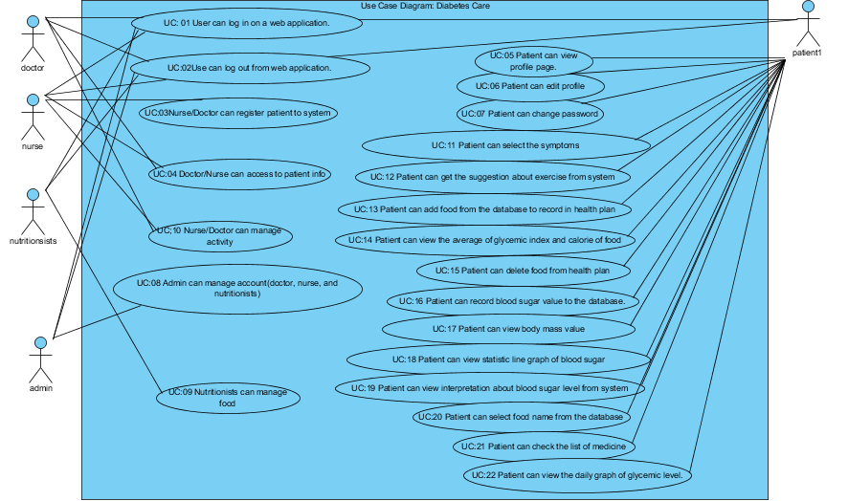

**Figure 1: Use Case diagram of Diabetes**

**Use Case Diagram: Authentication system.**

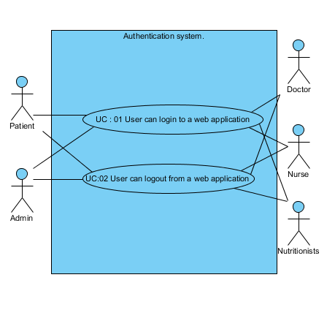

**Figure 2: Use Case diagram of Authentication system.**

**Use Case Diagram: Account management.**

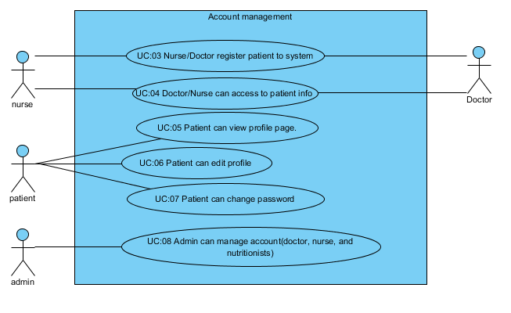

**Figure 3: Use Case diagram of Account management.**

**Use Case Diagram: Nutritionists management**

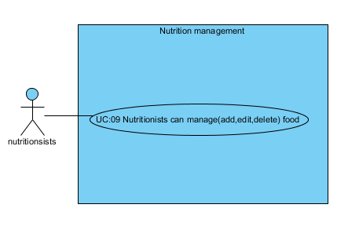

**Figure 4: Use Case diagram of Nutritionists management.**

**Use Case Diagram: Activity management**

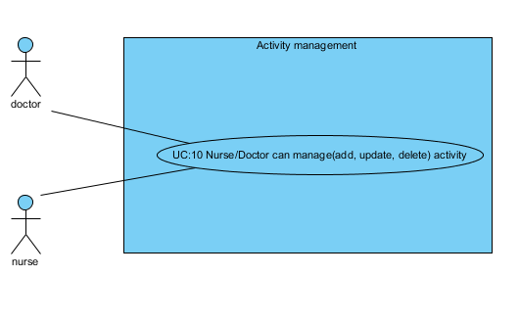

**Figure 5: Use Case diagram of Activity management.**

**Use Case Diagram: Activity plan and recommend system.**

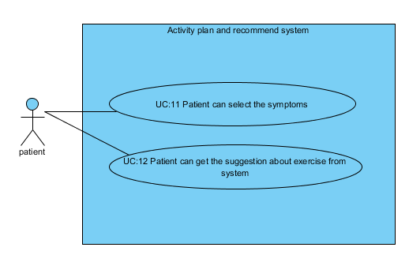

**Figure 6: Use Case diagram of Activity plan and recommend system.**

**Use Case Diagram: Nutrition plan system.**

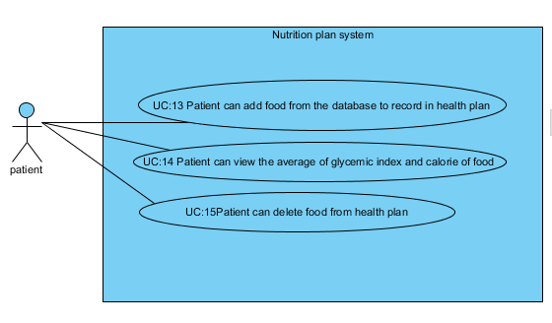

**Figure 7: Use Case diagram of Nutrition plan system.**

**Use Case Diagram: Health monitors system.**

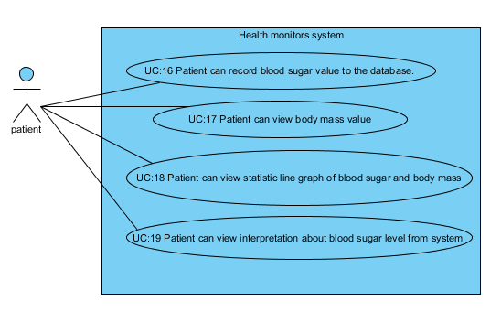

**Figure 8: Use Case diagram of Health monitors system.**

**Use Case Diagram: Behavior monitors system.**

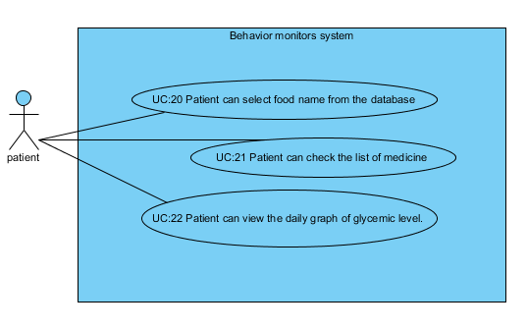

**Figure 9: Use Case diagram of Behavior monitors system.**

**4.2 Use Case Scenarios**

|  |  |  |  |  |  |
| --- | --- | --- | --- | --- | --- |
| Use Case ID | UC01 | | | | |
| Use Case Name | User can log in on a Web Application. | | | | |
| Created By | Jirayu Chinpongsuwan | | | Last Update By | Jirayu Chinpongsuwan |
| Date Created | 25/4/2016 | | | Last Revision Date | 25/4/2016 |
| Actors | Patient, Nutritionists, Admin | | | | |
| Description | User login to web application by use username and password | | | | |
| Trigger | - User selects login button. | | | | |
| Preconditions | - User must register in the system | | | | |
| Use Case Input Specification | | | | | |
| Input | type | Constraint | | | Example |
| UserName | string | - Must not empty.  - Username was already on the database.  - 8-20 character. | | | usertest |
| Password | string | - Must not empty  - Password was already on the database.  - 6-20 characters of capital or small alphabet letters or number. | | | passwordtest |
| Post conditions | - User login to system | | | | |
| Normal Flows | User | | System | | |
|  | 2. User must input data includes username and password.  3. User click login. | | 1. The system shall provide UI includes username and password.  4. The system shall verify (username and password)  5. The system shall redirect to index page. | | |
| Alternative Flow | In step 5 of Normal Flow, if users input wrong username or password.   1. The system shall display the error message “Invalid login attempt”. 2. The system shall return to step 2 of normal flow.   In step of 5 of Normal Flow, if users not input username or password.   1. The system shall display error message “The username field is required”, when user not input username. 2. The system shall display error message “The password field is required”, when user not input password. 3. The system shall return to step 2 of normal flow. | | | | |
| Exception Flow | - | | | | |
| Assumption | 1. Users understand English.  2. Users must have username and password in system | | | | |

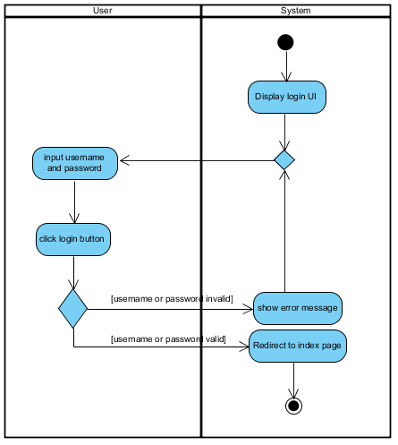

**Figure 9:** **AD: 01:** login.

|  |  |  |  |  |  |
| --- | --- | --- | --- | --- | --- |
| Use Case ID | UC02 | | | | |
| Use Case Name | User can log out from system. | | | | |
| Created By | Jirayu Chinpongsuwan | | | Last Update By | Jirayu Chinpongsuwan |
| Date Created | 25/4/2016 | | | Last Revision Date | 25/4/2016 |
| Actors | Patient, Nutritionists, Admin | | | | |
| Description | User logout from web application. | | | | |
| Trigger | - User selects logout button. | | | | |
| Preconditions | - User login to the Diabetes web application. | | | | |
| Use Case Input Specification | | | | | |
| Input | type | Constraint | | | Example |
| - | - | - | | | - |
| Post conditions | - User logout from system | | | | |
| Normal Flows | User | | System | | |
|  | 2. User must logout button. | | 1. The system shall provide “logout” button  3. The system shall destroy session.  4. The system shall redirect to index page. | | |
| Alternative Flow | - | | | | |
| Exception Flow | - | | | | |
| Assumption | 1. Users understand English. | | | | |

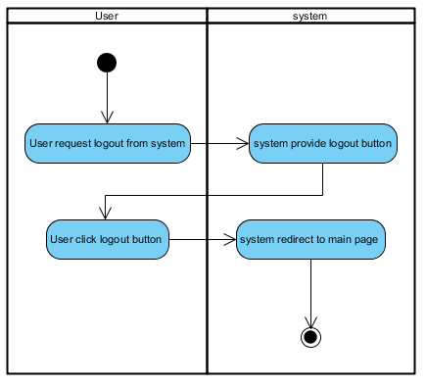

**Figure 10:** **AD: 02:** Patient logout.

|  |  |  |  |  |  |  |
| --- | --- | --- | --- | --- | --- | --- |
| Use Case ID | UC03 | | | | | |
| Use Case Name | Nurse/Doctor can register patient to the web application | | | | | |
| Created By | Jirayu Chinpongsuwan | | | Last Update By | Jirayu Chinpongsuwan | |
| Date Created | 25/4/2016 | | | Last Revision Date | 25/4/2016 | |
| Actors | Nurse, Patient | | | | | |
| Description | The nurse can enter patient (username, password, confirm password, email, first name, last name, age, gender, weight, height, address, diabetes type and start treatment) to the database server on a web application. | | | | | |
| Trigger | - Nurse or Patient selects register button on navigation. | | | | | |
| Preconditions | - | | | | | |
| Use Case Input Specification | | | | | | |
| Input | type | Constraint | | | | Example |
| username | string | - Must not empty.  - Must not already on the database.  - 8-20 character. | | | | usertest |
| password | string | - Must not empty  - 6-20 characters of capital or small alphabet letters or number | | | | Password1 |
| Confirm password | string | - Must be same with password  - Must not empty  - 6-20 characters of capital or small alphabet letters or number | | | | Password1 |
| e-mail | string | - email address format (made up of a local part, an @ symbol, than a domain part)  - Must not empty | | | | example@email.com |
| First name | string | Must not empty | | | | Jirayu |
| Last name | string | Must not empty | | | | Chinpongsuwan |
| age | int | - Must input to be number  - Must not empty | | | | 20 |
| weight | double | - Must input to be number  - Must not empty | | | | 60.00 |
| height | double | - Must input to be number  - Must not empty | | | | 175.00 |
| Gender | boolean | - Must not empty  - Must select between male = 0 and female = 1 | | | | 0 |
| Diabetes type | boolean | - Must not empty  - Must select between type1=0 and type2 = 1 | | | | 0 |
| Start treatment | Date | - Must not empty  - Must input to be date format. | | | | 12/12/2012 |
| address | String | -Must not empty | | | | Mang phayao 56000 |
| Post conditions | - Registration success the data must store on the database. | | | | | |
| Normal Flows | User | | System | | | |
|  | 2. User must input data includes username, password, confirm password, e-mail, first name, last name, gender, age, address, diabetes type, height, weight, and start treatment.  3. User must click “Submit” button. | | 1. The system shall provide UI includes username, password, confirm password, e-mail, first name, last name, gender, age, address, diabetes type, height, weight, and start treatment.  The system shall provide “Submit” button  4. The system shall verify data includes username, password, confirm password, e-mail, first name, last name, gender, age, address, diabetes type, height, weight, and start treatment. | | | |
| Alternative Flow | In step of 6 of Normal Flow, if users not input the data on field.   1. The system shall display error message the “The username field is required”, when the user does not input username. 2. The system shall display error message the “The Password field is required”, when the user does not input password. 3. The system shall provide error message the “first name field is required”, when the user does not input the first name. 4. The system shall provide error message the “last name field is required”, when user does not input the last name. 5. The system shall provide error message the “age field is required”, when the user does not input age. 6. The system shall provide error message the “address field is required”, when the user does not input address. 7. The system shall provide error message the “height field is required”, when the user does not input height. 8. The system shall provide error message the “Weight field is required”, when the user does not input weight. 9. The system shall return to step 2 of normal flow.   In step of 6 of Normal Flow, if users input wrong format.   1. The system shall provide error message the “email is invalid”, when user input wrong format e-mail. 2. The system shall provide error message “age is invalid”, when user input wrong format age. 3. The system shall provide error message “height must be a number”, when user input wrong format height. 4. The system shall provide error message “weight must be a number”, when user wrong input format weight. 5. The system shall return to step 2 of normal flow.   In step of 6 of Normal Flow, if users input email that already in the database.   1. The system shall provide error message the “email is already taken”, when the user input email is already in the database. 2. The system shall return to step 2 of normal flow.   In step of 6 of Normal Flow, if users input password less than 6 character.   1. The system shall provide error message “The password must be at least 6 characters long”, when the user input password less than 6 characters. 2. The system shall return to step 2 of normal flow. | | | | | |
| Exception Flow | - | | | | | |
| Assumption | 1. Users understand English. | | | | | |

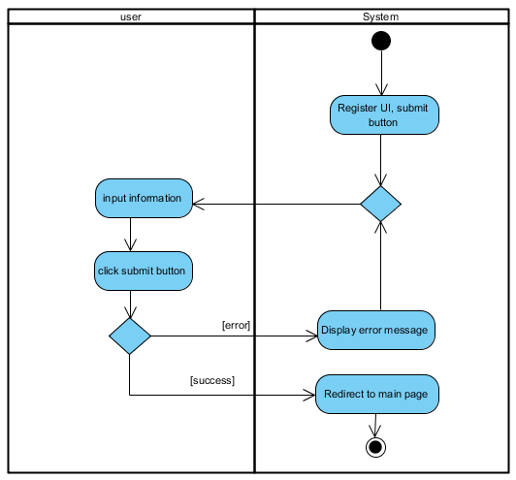

**Figure 11:** **AD: 03:** Registration.

|  |  |  |  |  |  |
| --- | --- | --- | --- | --- | --- |
| Use Case ID | UC04 | | | | |
| Use Case Name | Doctor/Nurse can access to patient info. | | | | |
| Created By | Jirayu Chinpongsuwan | | | Last Update By | Jirayu Chinpongsuwan |
| Date Created | 25/4/2016 | | | Last Revision Date | 25/4/2016 |
| Actors | Doctor, Nurse | | | | |
| Description | The doctor and nurse can access to patient information (first name, last name, age, gender, weight, height, diabetes type, blood sugar value, and start treatment). | | | | |
| Trigger | - Doctor or nurse selects patient list link button. | | | | |
| Preconditions | - Doctor login to the web application by doctor account.  - Nurse login to the web application by nurse account. | | | | |
| Use Case Input Specification | | | | | |
| Input | type | Constraint | | | Example |
| - | - | - | | | - |
| Post conditions | - Doctor access to patient info success.  - Nurse access to patient info success. | | | | |
| Normal Flows | User | | System | | |
|  | 3. The user input name of patient in search field  4.The user click “search” | | 1. The system shall provide table list of patient.  2. The system shall provide search field  5. The system shall verify name of patient.  6. The system shall display name of patient on table. | | |
| Alternative Flow | In step 5 of Normal Flows, if user input name that not already in the database.   1. The system shall display error message, when the doctor or nurse input patient name that not already in the database. 2. The user must input again.   In step 5 of Normal Flows, if user not input name on search field.   1. The system shall display error message, when the doctor or nurse not input name of patient on search field. 2. The user must input again. | | | | |
| Exception Flow | - | | | | |
| Assumption | 1. Users understand English. | | | | |

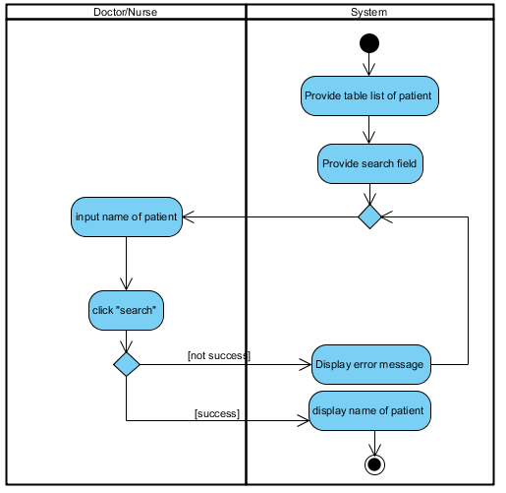

**Figure 12:** **AD: 04:** Doctor/Nurse can access to patient info.

|  |  |  |  |  |  |
| --- | --- | --- | --- | --- | --- |
| Use Case ID | UC05 | | | | |
| Use Case Name | View profile. | | | | |
| Created By | Jirayu Chinpongsuwan | | | Last Update By | Jirayu Chinpongsuwan |
| Date Created | 25/4/2016 | | | Last Revision Date | 25/4/2016 |
| Actors | Patient | | | | |
| Description | The patient can view information include first name, last name, age, gender, weight, height, address, medicine, diabetes type, blood sugar value, and start treatment on profile page. | | | | |
| Trigger | - User selects profile link button. | | | | |
| Preconditions | - User login to the Diabetes web application.. | | | | |
| Use Case Input Specification | | | | | |
| Input | type | Constraint | | | Example |
| - | - | - | | | - |
| Post conditions | - User can view the information of user profile. | | | | |
| Normal Flows | User | | System | | |
|  | 1. User click button link to profile. | | 2. The system shall redirect to profile page.  3. The system shall display his profile on profile page. | | |
| Alternative Flow | - | | | | |
| Exception Flow | - | | | | |
| Assumption | 1. Users understand English. | | | | |

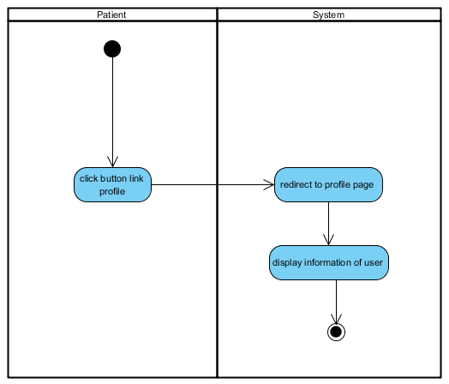

**Figure 13:** **AD: 05:** View information of his on profile page.

|  |  |  |  |  |  |
| --- | --- | --- | --- | --- | --- |
| Use Case ID | UC06 | | | | |
| Use Case Name | Edit profile | | | | |
| Created By | Jirayu Chinpongsuwan | | | Last Update By | Jirayu Chinpongsuwan |
| Date Created | 25/4/2016 | | | Last Revision Date | 25/4/2016 |
| Actors | Patient | | | | |
| Description | Patient can edit the information (first name, last name, a select box to choose gender, age, height, and weight) of his. | | | | |
| Trigger | - User selects profile link button. | | | | |
| Preconditions | - User login to the Diabetes web application. | | | | |
| Use Case Input Specification | | | | | |
| Input | type | Constraint | | | Example |
| First name | string | - | | | Jirayu |
| Last name | string | - | | | Chinpongsuwan |
| age | int | - Must input to be number  - Must not empty | | | 20 |
| weight | double | - Must input to be number  - Must not empty | | | 60.00 |
| height | double | - Must input to be number  - Must not empty | | | 175.00 |
| Gender | boolean | - Must not empty  - Must select between meal and female | | | male |
| Post conditions | - User can edit account success. | | | | |
| Normal Flows | User | | System | | |
|  | 2. Patient click profile button link.  5. Patient click “edit” button  7. Patient input new information includes first name, last name, gender, age height, weight.  8. User click save. | | 1. The system shall provide “profile link” button.  3. The system shall redirect to profile page.  4. The system provide “edit” button.  6. The system provides UI to edit information includes first name, last name, gender, age, height, weight.  9. The system shall verify input data includes first name, last name, gender, age, height, weight.  10. The system shall save change in data base | | |
| Alternative Flow | In step of 9 of Normal Flow, if users input wrong format height, and weight.   1. The system shall provide error message “The field Height must be a number”, when user input wrong format height. 2. The system shall provide error message “The field Weight must be a number”, when user wrong input format weight. 3. Users input again 4. The system shall return to step 7 of normal flow | | | | |
| Exception Flow | - | | | | |
| Assumption | 1. Users understand English. | | | | |

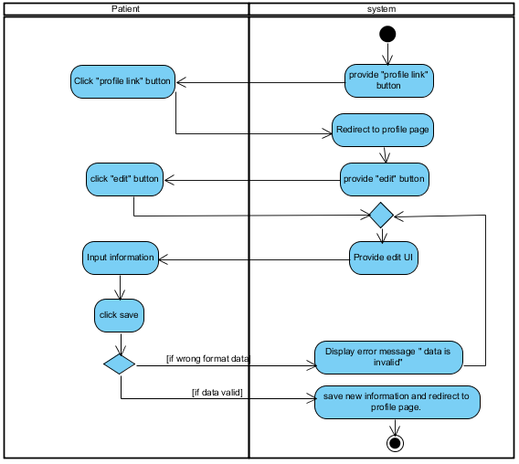

**Figure 13:** **AD: 06:** Edit account.

|  |  |  |  |  |  |
| --- | --- | --- | --- | --- | --- |
| Use Case ID | UC07 | | | | |
| Use Case Name | Chang password | | | | |
| Created By | Jirayu Chinpongsuwan | | | Last Update By | Jirayu Chinpongsuwan |
| Date Created | 25/4/2016 | | | Last Revision Date | 25/4/2016 |
| Actors | Patient | | | | |
| Description | Patient can change password for login. | | | | |
| Trigger | - User selects profile link button. | | | | |
| Preconditions | - Patient login to the Diabetes web application. | | | | |
| Use Case Input Specification | | | | | |
| Input | type | Constraint | | | Example |
| Current password | string | - Must already in the database  - Must not empty  - 6-20 characters of capital or small alphabet letters or number | | | passwordtest |
| New password | string | - Must not empty  - 6-20 characters of capital or small alphabet letters or number | | | passwordtest1 |
| Confirm password | string | Must be same new password | | | passwordtest1 |
| Post conditions | - Patient can change password success | | | | |
| Normal Flows | User | | System | | |
|  | 2. Patient click profile button link.  5. Patient click “change password” button  7. Patient input data include current password, new password  8. Patient click “submit”. | | 1. The system shall provide “profile link” button.  3. The system shall redirect to profile page.  4. The system provide “change password” button.  6. The system shall provide UI for change password includes current password, new password  9. The system shall verify input data include current password, new password  10. The system shall redirect to user profile page | | |
| Alternative Flow | In normal flow step 9. If the patient input current password not correct.   1. The system shall provide error message “Incorrect password”, when the patient input current password not correct. 2. The system shall return to step 7 of normal flow   In normal flow step 9. If the patient not input new password.   1. The system shall provide error message “The New password field is required”, when the patient not input new password. 2. The system shall return to step 7 of normal flow.   In normal flow step 9. If the patient input new password less than 6 character.   1. The system shall provide error message “The New password must be at least 6 characters long”, when the patient input new password less than 6 characters. 2. The system shall return to step 7 of normal flow.   In normal flow step 9. If the patient input new password and confirm password dose not match.   1. The system shall provide error message “new password and confirm password does not match”, when the patient input a new password and confirm password does not match. 2. The system shall return to step 7 of normal flow. | | | | |
| Exception Flow | - | | | | |
| Assumption | 1. Users understand English. | | | | |

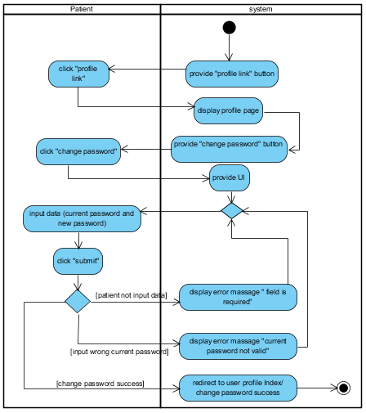

**Figure 14:** **AD: 07:** Chang password.

|  |  |  |  |  |  |
| --- | --- | --- | --- | --- | --- |
| Use Case ID | UC08 | | | | |
| Use Case Name | Admin add user account | | | | |
| Created By | Jirayu Chinpongsuwan | | | Last Update By | Jirayu Chinpongsuwan |
| Date Created | 25/4/2016 | | | Last Revision Date | 25/4/2016 |
| Actors | Admin | | | | |
| Description | Admin can add nutritionists, nurse, and doctor to the system by input username, password, email and select role. | | | | |
| Trigger | - Admin clicks account management. | | | | |
| Preconditions | - Admin login to the administration system. | | | | |
| Use Case Input Specification | | | | | |
| Input | type | Constraint | | | Example |
| username | string | Must not empty | | | username |
| password | string | - Must not empty  - 6-20 characters of capital or small alphabet letters or number | | | - |
| email | string | - email address format made up of a local part, an @ symbol, than a domain part  - Must not empty | | | example@email.com |
| Post conditions | - Admin add account success. | | | | |
| Normal Flows | User | | System | | |
|  | 2. Admin click “create new”  4. Admin input info includes username, password, email and role.  5. Admin click “create” button. | | 1.The system provide “create new” button    3. The system provides UI include username, password, email and role.  6. The system shall verify input info includes username, password, email and role.  7. The system shall redirect to admin page, when create new user account success. | | |
| Alternative Flow | In normal flow step 6 If the admin input e-mail that already in the database.   1. The system shall provide error message the “email is already taken”, when the admin input email is already in the database. 2. The system shall return to step 3 of normal flow.   In normal flow step 6 If the admin input wrong format e-mail.   1. The system shall provide error message “the e-mail is invalid”, when the admin input wrong format e-mail. 2. The system shall return to step 3 of normal flow.   In normal flow step 6 If the admin input password less than 6 characters.   1. The system shall provide error message “The password must be at least 6 characters long”, when the admin input new password less than 6 characters. 2. The system shall return to step 3 of normal flow. | | | | |
| Exception Flow | - | | | | |
| Assumption | 1. Users understand English. | | | | |

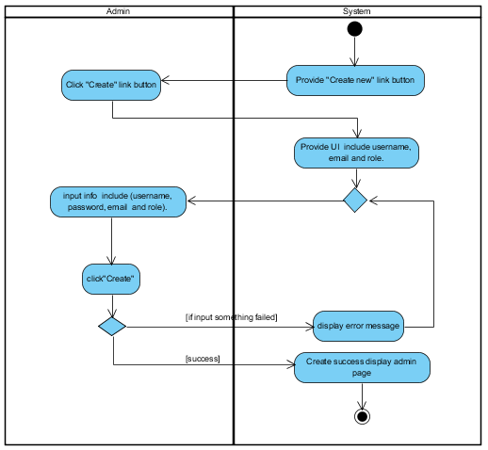

**Figure 15:** **AD: 08:** Admin add account.

|  |  |  |  |  |  |
| --- | --- | --- | --- | --- | --- |
| Use Case ID | UC09 | | | | |
| Use Case Name | Admin edit user account | | | | |
| Created By | Jirayu Chinpongsuwan | | | Last Update By | Jirayu Chinpongsuwan |
| Date Created | 25/4/2016 | | | Last Revision Date | 25/4/2016 |
| Actors | Admin | | | | |
| Description | Admin can edit username, password, and role on user account manage page. | | | | |
| Trigger | - Admin clicks account management. | | | | |
| Preconditions | - Admin login to the administration system. | | | | |
| Use Case Input Specification | | | | | |
| Input | type | Constraint | | | Example |
| password | string | - Must not empty  - 6-12 characters of capital or small alphabet letters or number | | | - |
| email | string | - email address format (made up of a local part, an @ symbol, than a domain part)  - Must not empty | | | example@email.com |
| Post conditions | - Admin edit account success. | | | | |
| Normal Flows | User | | System | | |
|  | 2. Admin click “edit”.  4. Admin input new info includes e-mail, password, and role.  5. Admin click “submit” button. | | 1. The system provide “edit” button  3. The system provides UI for edit includes e-mail, password, and role.  6. The system shall verify input data includes e-mail, password, and role.  7. The system shall redirect to admin page, when edit user account success. | | |
| Alternative Flow | In normal flow step 6. If the admin input e-mail that already in the database.   1. The system shall provide error message the “email is already taken”, when the admin input email is already in the database. 2. The system shall return to step 3 of normal flow.   In normal flow step 6. If the admin input wrong format e-mail.   1. The system shall provide error message “the e-mail is invalid”, when the admin input wrong format e-mail. 2. The system shall return to step 3 of normal flow.   In normal flow step 6. If the admin input password less than 6 characters.   1. The system shall provide error message “The password must be at least 6 characters long”, when the admin input new password less than 6 characters. 2. The system shall return to step 3 of normal flow. | | | | |
| Exception Flow | - | | | | |
| Assumption | 1. Users understand English. | | | | |

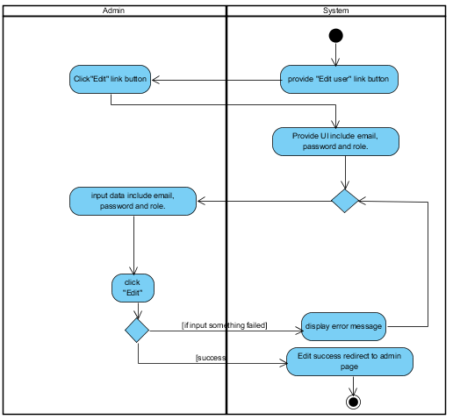

**Figure 15:** **AD: 09:** Admin edit account.

|  |  |  |  |  |  |
| --- | --- | --- | --- | --- | --- |
| Use Case ID | UC10 | | | | |
| Use Case Name | Admin delete user account. | | | | |
| Created By | Jirayu Chinpongsuwan | | | Last Update By | Jirayu Chinpongsuwan |
| Date Created | 25/4/2016 | | | Last Revision Date | 25/4/2016 |
| Actors | Admin | | | | |
| Description | Admin can delete nutritionists, nurse, and doctor from the system. | | | | |
| Trigger | - Admin clicks account management. | | | | |
| Preconditions | - Admin login to the administration system. | | | | |
| Use Case Input Specification | | | | | |
| Input | type | Constraint | | | Example |
| - | - | - | | | - |
| Post conditions | - Admin deletes account success. | | | | |
| Normal Flows | User | | System | | |
|  | 2. Admin click “delete” button.  4. Admin must confirm delete. | | 1. The system provide “delete” button  3. The system shall display confirm message.  5. The system shall delete account that selected. | | |
| Alternative Flow | In step 4 of Normal Flows, if user confirm delete select “yes”.   1. The system shall delete success.   In step 4 of Normal Flows, if user confirm delete select “cancel”.   1. The system shall cancel delete data process. | | | | |
| Exception Flow | - | | | | |
| Assumption | 1. Users understand English. | | | | |

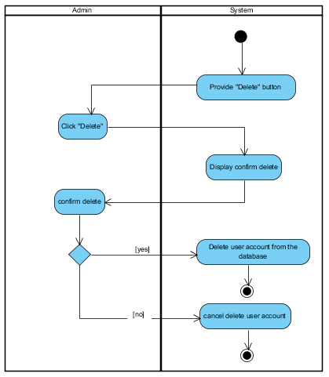

**Figure 15:** **AD: 10:** Admin delete account.

|  |  |  |  |  |  |
| --- | --- | --- | --- | --- | --- |
| Use Case ID | UC11 | | | | |
| Use Case Name | Add food | | | | |
| Created By | Jirayu Chinpongsuwan | | | Last Update By | Jirayu Chinpongsuwan |
| Date Created | 25/4/2016 | | | Last Revision Date | 25/4/2016 |
| Actors | Nutritionists | | | | |
| Description | Nutritionists can add food on nutrition management page. | | | | |
| Trigger | - Nutritionists click nutrition management. | | | | |
| Preconditions | - Nutritionists login to the diabetes web application. | | | | |
| Use Case Input Specification | | | | | |
| Input | type | Constraint | | | Example |
| Food name | string | - Must not empty. | | | foodtest |
| Glycemic index | double | - Must not empty.  - Must be a number. | | | 60.00 |
| Calorie | double | - Must not empty.  - Must be a number. | | | 100.00 |
| Post conditions | - Nutritionists can add food success. | | | | |
| Normal Flows | User | | System | | |
|  | 2. Nutritionists click “create new”  4. Nutritionists input info includes food name, the glycemic index of food, and food calorie.  5. Nutritionists click “create” button. | | 1.The system provide “create new” button    3. The system provides UI include food name, the glycemic index of food, and food calorie.  6. The system shall verify input data includes food name, the glycemic index of food, and food calorie.  7. The system shall redirect to nutrition page, when create food success. | | |
| Alternative Flow | In normal flow step 6. If the nutritionists input character on glycemic index field   1. The system shall provide error message “The glycemic index must be a number”, when the nutritionists input character on glycemic index field. 2. The system shall return to step 3 of normal flow.   In normal flow step 6. If the nutritionists not input calorie.   1. The system shall provide error message “The calorie must be a number”, when the nutritionists not input calorie. 2. The system shall return to step 3 of normal flow.   In normal flow step 6. If the nutritionists input character on glycemic index field.   1. The system shall provide error message “The glycemic index field is request”, when the nutritionists input character on glycemic index field. 2. The system shall return to step 3 of normal flow.   In normal flow step 6. If the nutritionists not input calorie.   1. The system shall provide error message “The calorie field is request”, when the nutritionists not input calorie. 2. The system shall return to step 3 of normal flow. | | | | |
| Exception Flow | - | | | | |
| Assumption | 1. Users understand English. | | | | |

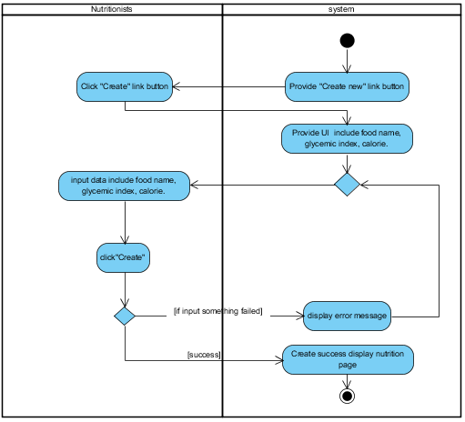

**Figure 15:** **AD: 11:** Nutritionists add food.

|  |  |  |  |  |  |
| --- | --- | --- | --- | --- | --- |
| Use Case ID | UC12 | | | | |
| Use Case Name | Edit food | | | | |
| Created By | Jirayu Chinpongsuwan | | | Last Update By | Jirayu Chinpongsuwan |
| Date Created | 25/4/2016 | | | Last Revision Date | 25/4/2016 |
| Actors | Nutritionists | | | | |
| Description | Nutritionists can edit food on nutrition management page. | | | | |
| Trigger | - Nutritionists click manage foods. | | | | |
| Preconditions | - Nutritionists login to the Diabetes web application. | | | | |
| Use Case Input Specification | | | | | |
| Input | type | Constraint | | | Example |
| Food name | string | - Must not empty. | | | newfood |
| Glycemic index | double | - Must not empty.  - Must be a number. | | | 61.00 |
| Calorie | double | - Must not empty.  - Must be a number. | | | 110.00 |
| Post conditions | - Nutritionists can edit nutrition success. | | | | |
| Normal Flows | User | | System | | |
|  | 2. The nutritionists click “edit”.  4. Nutritionists input new info which includes food name, the glycemic index of food, and food calorie.  5. The nutritionists click “save” button. | | 1. The system provide “edit” button  3. The system provides UI for edit which include food name, the glycemic index of food, and food calorie.  6. The system shall verify input data includes food name, the glycemic index of food, and food calorie.  7. The system shall redirect to nutrition page, when edit food success | | |
| Alternative Flow | In normal flow step 6. If the nutritionists input character on glycemic index field.   1. The system shall provide error message “The glycemic index must be a number”, when the nutritionists input character on glycemic index field 2. The system shall return to step 3 of normal flow.   In normal flow step 6. If the nutritionists not input calorie.   1. The system shall provide error message “The calorie must be a number”, when the nutritionists not input calorie. 2. The system shall return to step 3 of normal flow.   In normal flow step 6. If the nutritionists input character on glycemic index field.   1. The system shall provide error message “The glycemic index field is request”, when the nutritionists input character on glycemic index field. 2. The system shall return to step 3 of normal flow.   In normal flow step 6. If the nutritionists not input calorie.   1. The system shall provide error message “The calorie field is request”, when the nutritionists not input calorie. 2. The system shall return to step 3 of normal flow. | | | | |
| Exception Flow | - | | | | |
| Assumption | 1. Users understand English. | | | | |

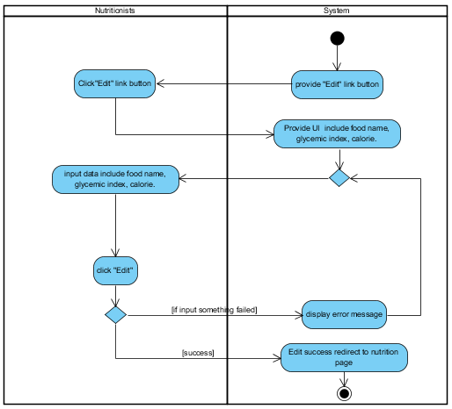

**Figure 15:** **AD: 12:** Nutritionists edit food.

|  |  |  |  |  |  |
| --- | --- | --- | --- | --- | --- |
| Use Case ID | UC13 | | | | |
| Use Case Name | Delete food | | | | |
| Created By | Jirayu Chinpongsuwan | | | Last Update By | Jirayu Chinpongsuwan |
| Date Created | 25/4/2016 | | | Last Revision Date | 25/4/2016 |
| Actors | Nutritionists | | | | |
| Description | Nutritionists can delete food on nutrition management page. | | | | |
| Trigger | - Nutritionists click manage foods. | | | | |
| Preconditions | - Nutritionists login to the diabetes web application. | | | | |
| Use Case Input Specification | | | | | |
| Input | type | Constraint | | | Example |
| - | - | - | | | - |
| Post conditions | - Nutritionists can delete nutrition success. | | | | |
| Normal Flows | User | | System | | |
|  | 2. The nutritionists click “delete” button.  4. The nutritionists confirm delete food. | | 1. The system provide “delete” button  3. The system shall display confirm delete.  5. The system shall delete food that selected. | | |
| Alternative Flow | In step 4 of Normal Flows, if user confirm delete select “yes”.   1. The system shall delete success.   In step 4 of Normal Flows, if user confirm delete select “cancel”.   1. The system shall cancel delete data process. | | | | |
| Exception Flow | - | | | | |
| Assumption | 1. Users understand English. | | | | |

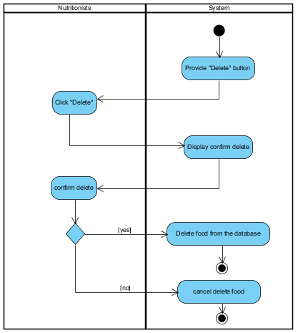

**Figure 15:** **AD: 13:** Nutritionists delete food.

|  |  |  |  |  |  |  |  |
| --- | --- | --- | --- | --- | --- | --- | --- |
| Use Case ID | UC14 | | | | | | |
| Use Case Name | Add exercise | | | | | | |
| Created By | Jirayu Chinpongsuwan | | | | Last Update By | | Jirayu Chinpongsuwan |
| Date Created | 25/4/2016 | | | | Last Revision Date | | 25/4/2016 |
| Actors | Nurse, Doctor | | | | | | |
| Description | Nurse or doctor can add exercise on activity management page. | | | | | | |
| Trigger | - Nurse or doctor click activity management page. | | | | | | |
| Preconditions | - Nurse or doctor login to the diabetes web application. | | | | | | |
| Use Case Input Specification | | | | | | | |
| Input | | type | Constraint | | | Example | |
| symptom | | string | - | | | Symptom test | |
| suggestion | | string | - | | | Suggestion test | |
| proper exercise | | string | - | | | Proper exercise test | |
| exercise inappropriate | | string | - | | | Exercise inappropriate test | |
| step exercise | | string | - | | | Step exercise test | |
| Post conditions | | - Nurse or doctor can add exercise success. | | | | | |
| Normal Flows | | User | | System | | | |
|  | | 2. Nurse or doctor click “create new”  4. Nurse or Doctor input info which includes input field symptom, suggestion, proper exercise, exercise inappropriate, and step exercise.  5. Nurse or doctor click “submit” button. | | 1.The system provide “create new” button    3. The system provides UI which includes input field symptom, suggestion, proper exercise, exercise inappropriate, and step exercise.  6. The system shall redirect to exercise page, when create success. | | | |
| Alternative Flow | | - | | | | | |
| Exception Flow | | - | | | | | |
| Assumption | | 1. Users understand English. | | | | | |

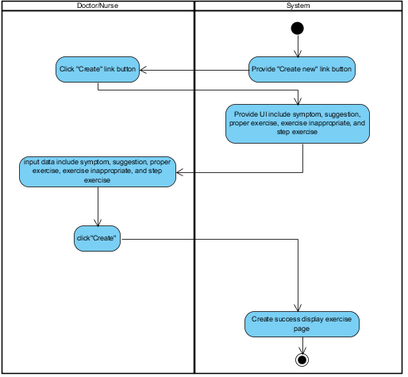

**Figure 15:** **AD: 14:** Doctor/Nurse adds exercise.

|  |  |  |  |  |  |  |  |
| --- | --- | --- | --- | --- | --- | --- | --- |
| Use Case ID | UC15 | | | | | | |
| Use Case Name | Edit exercise | | | | | | |
| Created By | Jirayu Chinpongsuwan | | | | Last Update By | | Jirayu Chinpongsuwan |
| Date Created | 25/4/2016 | | | | Last Revision Date | | 25/4/2016 |
| Actors | Nurse, Doctor | | | | | | |
| Description | Nurse or doctor can edit exercise on activity management page. | | | | | | |
| Trigger | - Nurse or doctor click activity management page. | | | | | | |
| Preconditions | - Nurse or doctor login to the diabetes web application. | | | | | | |
| Use Case Input Specification | | | | | | | |
| Input | | type | Constraint | | | Example | |
| symptom | | string | - | | | Symptom test2 | |
| suggestion | | string | - | | | Suggestion test2 | |
| proper exercise | | string | - | | | Proper exercise test2 | |
| exercise inappropriate | | string | - | | | Exercise inappropriate test2 | |
| step exercise | | string | - | | | Step exercise test2 | |
| Post conditions | | - Nurse or doctor can edit exercise success. | | | | | |
| Normal Flows | | User | | System | | | |
|  | | 2. Nurse or doctor click “edit”.  4. Nurse or doctor input new info which includes input field symptom, suggestion, proper exercise, exercise inappropriate, and step exercise.  5. Nurse or Doctor click “submit” button. | | 1. The system provide “edit” button  3. The system provides UI for edit which includes input field symptom, suggestion, proper exercise, exercise inappropriate, and step exercise.  6. The system shall redirect to exercise page, when edit success. | | | |
| Alternative Flow | | - | | | | | |
| Exception Flow | | - | | | | | |
| Assumption | | 1. Users understand English. | | | | | |

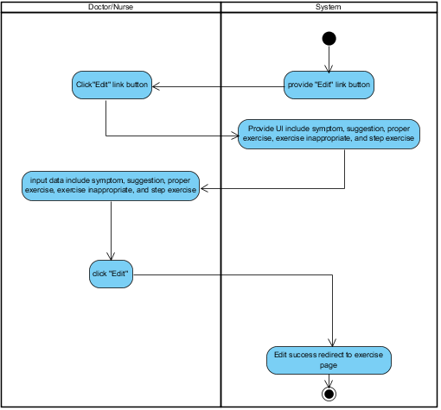

**Figure 15:** **AD: 15:** Doctor/Nurse edits exercise.

|  |  |  |  |  |  |
| --- | --- | --- | --- | --- | --- |
| Use Case ID | UC16 | | | | |
| Use Case Name | Delete exercise | | | | |
| Created By | Jirayu Chinpongsuwan | | | Last Update By | Jirayu Chinpongsuwan |
| Date Created | 25/4/2016 | | | Last Revision Date | 25/4/2016 |
| Actors | Nurse, Doctor | | | | |
| Description | Nurse or doctor can delete exercise on activity management page. | | | | |
| Trigger | - Nurse or doctor click activity management page. | | | | |
| Preconditions | - Nurse or doctor login to the diabetes web application. | | | | |
| Use Case Input Specification | | | | | |
| Input | type | Constraint | | | Example |
| - | - | - | | | - |
| Post conditions | - Nurse or doctor can delete exercise success. | | | | |
| Normal Flows | User | | System | | |
|  | 2. The nurse/doctor click “delete” button.  4. The nurse/doctor confirms delete exercise. | | 1. The system provide “delete” button  3. The system shall display confirm delete.  5. The system shall delete exercise that selected. | | |
| Alternative Flow | In step 4 of Normal Flows, if user confirm delete select “yes”.   1. The system shall delete success.   In step 4 of Normal Flows, if user confirm delete select “cancel”.   1. The system shall cancel delete data process. | | | | |
| Exception Flow | - | | | | |
| Assumption | 1. Users understand English. | | | | |

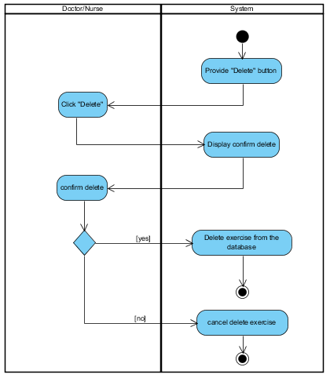

**Figure 15:** **AD: 16:** Doctor/Nurse deletes exercise.

|  |  |  |  |  |  |
| --- | --- | --- | --- | --- | --- |
| Use Case ID | UC17 | | | | |
| Use Case Name | Select the symptoms | | | | |
| Created By | Jirayu Chinpongsuwan | | | Last Update By | Jirayu Chinpongsuwan |
| Date Created | 25/4/2016 | | | Last Revision Date | 25/4/2016 |
| Actors | Patient | | | | |
| Description | Patient can select the symptoms on health plan page. | | | | |
| Trigger | - Patient selects health plan link button. | | | | |
| Preconditions | - Patient login to the web application. | | | | |
| Use Case Input Specification | | | | | |
| Input | type | Constraint | | | Example |
| - | - | - | | | - |
| Post conditions | - Patient can select the symptoms success. | | | | |
| Normal Flows | User | | System | | |
|  | 2. Patient must select symptoms from drop down list.  4. Patient click “select”. | | 1. The system shall provide drop down list on health plan page.  3. The system provide “select button” | | |
| Alternative Flow | - | | | | |
| Exception Flow | - | | | | |
| Assumption | 1. Users understand English. 2. Patient must be member of web application. | | | | |

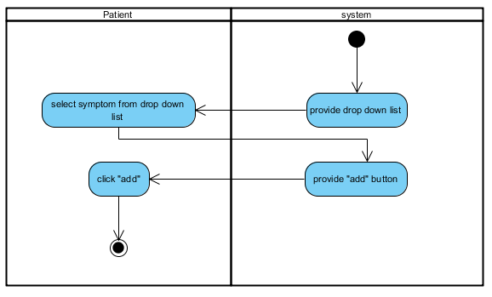

**Figure 18:** **AD: 17:** Select the symptoms.

|  |  |  |  |  |  |
| --- | --- | --- | --- | --- | --- |
| Use Case ID | UC18 | | | | |
| Use Case Name | Get exercise suggestion. | | | | |
| Created By | Jirayu Chinpongsuwan | | | Last Update By | Jirayu Chinpongsuwan |
| Date Created | 25/4/2016 | | | Last Revision Date | 25/4/2016 |
| Actors | Patient | | | | |
| Description | Patient can get the suggestion about exercise from system. | | | | |
| Trigger | - Patient selects health plan link button. | | | | |
| Preconditions | - Patient login to the web application. | | | | |
| Use Case Input Specification | | | | | |
| Input | type | Constraint | | | Example |
| - | - | - | | | - |
| Post conditions | - Patient gets the suggestion about exercise from system. | | | | |
| Normal Flows | User | | System | | |
|  | 2. Patient must select symptoms from drop down list.  4. Patient click “select”. | | 1. The system shall provide drop down list on health plan page.  3. The system provide “select button”  5. The system displays the exercise suggestion to patient. | | |
| Alternative Flow | - | | | | |
| Exception Flow | - | | | | |
| Assumption | 1. Users understand English. 2. Patient must be member of web application. | | | | |

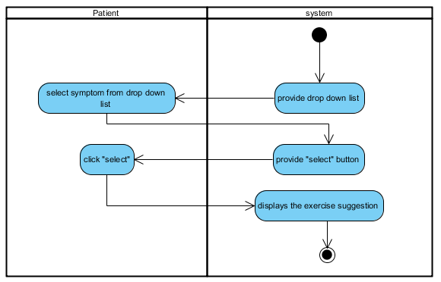

**Figure 19:** **AD: 18:** Get exercise suggestion.

|  |  |  |  |  |  |
| --- | --- | --- | --- | --- | --- |
| Use Case ID | UC19 | | | | |
| Use Case Name | Add food to record health plan. | | | | |
| Created By | Jirayu Chinpongsuwan | | | Last Update By | Jirayu Chinpongsuwan |
| Date Created | 25/4/2016 | | | Last Revision Date | 25/4/2016 |
| Actors | Patient | | | | |
| Description | Patient can add food from the database to record in health plan. | | | | |
| Trigger | - Patient selects health plan link button. | | | | |
| Preconditions | - Patient login to the Diabetes web application. | | | | |
| Use Case Input Specification | | | | | |
| Input | type | Constraint | | | Example |
| - | - | - | | | - |
| Post conditions | - Patient can record the foods to health plan success. | | | | |
| Normal Flows | User | | System | | |
|  | 2. Patient must select.  4. Patient must click add. | | 1. The system shall provide drop down list of food.  3. The system shall provide add food button. | | |
| Alternative Flow | - | | | | |
| Exception Flow | - | | | | |
| Assumption | 1. Users understand English. 2. Users must be member of web application. | | | | |

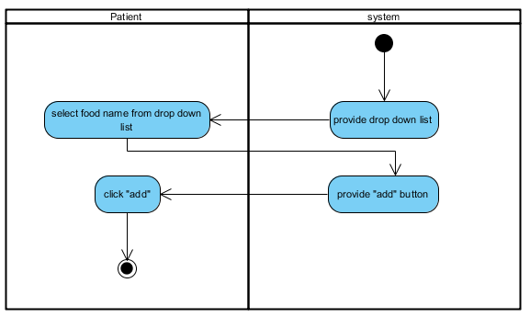

**Figure 20:** **AD: 19:** Add food to record health plan.

|  |  |  |  |  |  |
| --- | --- | --- | --- | --- | --- |
| Use Case ID | UC20 | | | | |
| Use Case Name | View the average of glycemic index and calorie. | | | | |
| Created By | Jirayu Chinpongsuwan | | | Last Update By | Jirayu Chinpongsuwan |
| Date Created | 25/4/2016 | | | Last Revision Date | 25/4/2016 |
| Actors | Patient | | | | |
| Description | Patient can view the average of glycemic index and calorie of food in the selected plan. | | | | |
| Trigger | - Patient selects health plan link button. | | | | |
| Preconditions | - Patient login to system. | | | | |
| Use Case Input Specification | | | | | |
| Input | type | Constraint | | | Example |
| - | - | - | | | - |
| Post conditions | - The system displays the average of glycemic index and calorie of food in the selected plan. | | | | |
| Normal Flows | User | | System | | |
|  | 4. Patient views the result average of glycemic index and calorie of food. | | 1. The system request data of food from food plan the database.  2. The system shall calculate the average of average of glycemic index and calorie of food.  3. The system provides text for display result. | | |
| Alternative Flow | - | | | | |
| Exception Flow | - | | | | |
| Assumption | 1. Users understand English. 2. Users must be member of web application. | | | | |

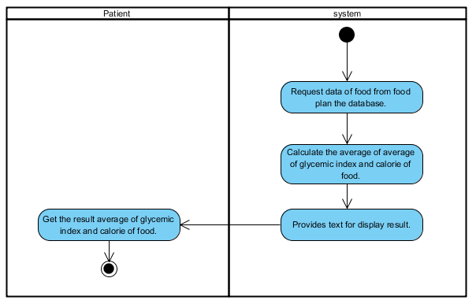

**Figure 21:** **AD: 20:** View the average of glycemic index and calorie.

|  |  |  |  |  |  |
| --- | --- | --- | --- | --- | --- |
| Use Case ID | UC21 | | | | |
| Use Case Name | Delete food from health plan | | | | |
| Created By | Jirayu Chinpongsuwan | | | Last Update By | Jirayu Chinpongsuwan |
| Date Created | 25/4/2016 | | | Last Revision Date | 25/4/2016 |
| Actors | Patient | | | | |
| Description | Patient can delete food from health plan. | | | | |
| Trigger | - Patient selects health plan link button. | | | | |
| Preconditions | - Patient login to system. | | | | |
| Use Case Input Specification | | | | | |
| Input | type | Constraint | | | Example |
| - | - | - | | | - |
| Post conditions | - Patient can delete food from his health plan success. | | | | |
| Normal Flows | User | | System | | |
|  | 2. Patient must select food.  3. Patient must click delete. | | 1. The system shall provide food name.  4. The system shall delete food from health plan. | | |
| Alternative Flow | - | | | | |
| Exception Flow | - | | | | |
| Assumption | 1. Users understand English. 2. Users must be Patient of web application. | | | | |

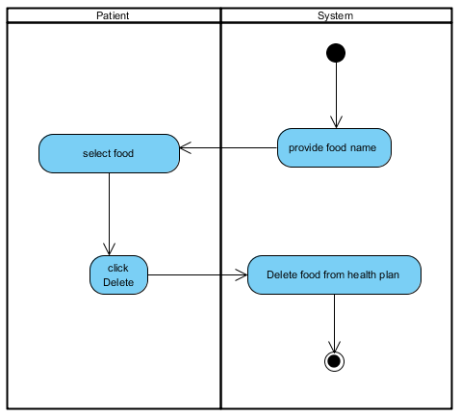

**Figure 22:** **AD: 21:** Delete food from health plan.

|  |  |  |  |  |  |
| --- | --- | --- | --- | --- | --- |
| Use Case ID | UC22 | | | | |
| Use Case Name | Add glycemic. | | | | |
| Created By | Jirayu Chinpongsuwan | | | Last Update By | Jirayu Chinpongsuwan |
| Date Created | 25/4/2016 | | | Last Revision Date | 25/4/2016 |
| Actors | Patient | | | | |
| Description | Patient can record blood sugar value to the database. | | | | |
| Trigger | - Patient selects health plan link button. | | | | |
| Preconditions | - Patient login to system. | | | | |
| Use Case Input Specification | | | | | |
| Input | type | Constraint | | | Example |
| Blood sugar | double | - Must not input negative value  - Must input to be number | | | 102.00 |
| Post conditions | - Patient can add the blood sugar value to the system success. | | | | |
| Normal Flows | User | | System | | |
|  | 2. Patient must input blood sugar value.  3. Patient must click add. | | 1. The system shall provide text field for add glycemic to user and provide add button.  4. The system shall verify input data.  5. The system shall record data in the database | | |
| Alternative Flow | In normal flow step 2. If the patient input wrong format blood sugar. The system display error message “blood sugar is invalid”   1. The patient must input data again. 2. The system shall resume to step 2 of normal flow   In normal flow step 2. If the patient input blood sugar minus value.   1. The system display error message “blood sugar cannot be negative”. 2. The patient must input data again. 3. The system shall resume to step 2 of normal flow | | | | |
| Exception Flow | - | | | | |
| Assumption | 1. Users understand English. 2. Users must be member of web application. | | | | |

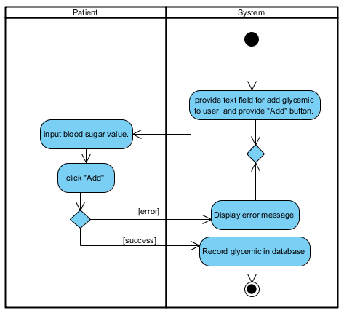

**Figure 23:** **AD: 22:** of Add glycemic.

|  |  |  |  |  |  |
| --- | --- | --- | --- | --- | --- |
| Use Case ID | UC23 | | | | |
| Use Case Name | View BMI. | | | | |
| Created By | Jirayu Chinpongsuwan | | | Last Update By | Jirayu Chinpongsuwan |
| Date Created | 25/4/2016 | | | Last Revision Date | 25/4/2016 |
| Actors | Patient | | | | |
| Description | Patient can view body mass value that calculated by using BMI = weight (Kg) / (height (m) * height (m)). | | | | |
| Trigger | - Patient selects health plan link button. | | | | |
| Preconditions | - Patient login to system. | | | | |
| Use Case Input Specification | | | | | |
| Input | type | Constraint | | | Example |
| - | - | - | | | - |
| Post conditions | Patient can view body mass value. | | | | |
| Normal Flows | User | | System | | |
|  | 4. Patient views the result BMI. | | 1. The system request data of patient (weight and height) from the database.  2. The system shall calculated by using BMI = weight (Kg) / (height (m) * height (m)).  3. The system provides text for display result. | | |
| Alternative Flow | - | | | | |
| Exception Flow | - | | | | |
| Assumption | 1. Users understand English. 2. Users must be member of web application. | | | | |

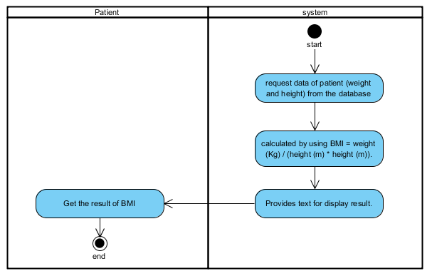

**Figure 24:** **AD: 23:** View BMI.

|  |  |  |  |  |  |
| --- | --- | --- | --- | --- | --- |
| Use Case ID | UC24 | | | | |
| Use Case Name | View BMR. | | | | |
| Created By | Jirayu Chinpongsuwan | | | Last Update By | Jirayu Chinpongsuwan |
| Date Created | 25/4/2016 | | | Last Revision Date | 25/4/2016 |
| Actors | Patient | | | | |
| Description | Patient can view body mass value that calculated by usingB $MR\left(male\right)=66+\left(13.7 ×weight \left(kg\right)\right)+(5 ×\left(height\left(cm\right)\right)-(6.8 ×age)$ or $BMR\left(female\right)=665+\left(9.6×weight \left(kg\right)\right)+(1.8×\left(height\left(cm\right)\right)-(4.7×age)$. | | | | |
| Trigger | - Patient selects health plan link button. | | | | |
| Preconditions | - Patient login to system. | | | | |
| Use Case Input Specification | | | | | |
| Input | type | Constraint | | | Example |
| - | - | - | | | - |
| Post conditions | Patient can view basal metabolic rate. | | | | |
| Normal Flows | User | | System | | |
|  | 4. Patient views the result BMR. | | 1. The system request data of patient (weight, height and gender) from the database. 2. The system shall calculated by using B $MR\left(male\right)=66+\left(13.7 ×weight \left(kg\right)\right)+(5 ×\left(height\left(cm\right)\right)-(6.8 ×age)$ Or $BMR\left(female\right)=665+\left(9.6×weight \left(kg\right)\right)+(1.8×\left(height\left(cm\right)\right)-(4.7×age)$ 3. The system provides text for display result. | | |
| Alternative Flow | - | | | | |
| Exception Flow | - | | | | |
| Assumption | 1. Users understand English. 2. Users must be member of web application. | | | | |

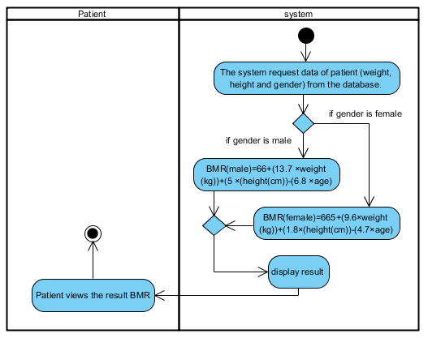

**Figure 25:** **AD: 24:** View BMR.

|  |  |  |  |  |  |
| --- | --- | --- | --- | --- | --- |
| Use Case ID | UC25 | | | | |
| Use Case Name | View blood sugar and body mass graph. | | | | |
| Created By | Jirayu Chinpongsuwan | | | Last Update By | Jirayu Chinpongsuwan |
| Date Created | 25/4/2016 | | | Last Revision Date | 25/4/2016 |
| Actors | Patient | | | | |
| Description | Patient can view statistic line graph (x = blood sugar value, y = date) of blood sugar and body mass. | | | | |
| Trigger | - Patient selects health plan link button. | | | | |
| Preconditions | - Patient login to system. | | | | |
| Use Case Input Specification | | | | | |
| Input | type | Constraint | | | Example |
| - | - | - | | | - |
| Post conditions | - Display blood sugar value and body mass value on graph. | | | | |
| Normal Flows | User | | System | | |
|  | 5. The patient view display graph. | | 1. The system shall provide line graph.  2. The system request data of blood sugar value from the database and BMI value from method code.  3. The system request the data value of blood sugar and body mass to using on graph  4. The system display line graph to patient. | | |
| Alternative Flow | - | | | | |
| Exception Flow | - | | | | |
| Assumption | 1. Users understand English. 2. Users must be Patient of web application. | | | | |

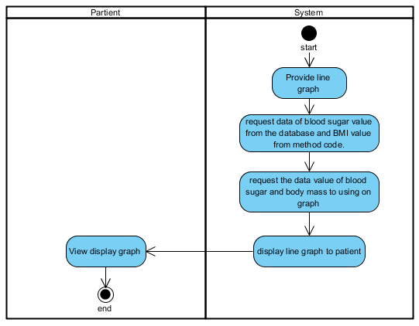

**Figure 26:** **AD: 25:** View glycemic graph.

|  |  |  |  |  |  |
| --- | --- | --- | --- | --- | --- |
| Use Case ID | UC26 | | | | |
| Use Case Name | View interpretation of blood sugar. | | | | |
| Created By | Jirayu Chinpongsuwan | | | Last Update By | Jirayu Chinpongsuwan |
| Date Created | 25/4/2016 | | | Last Revision Date | 25/4/2016 |
| Actors | Patient | | | | |
| Description | Patient can view interpretation about blood sugar level from system. | | | | |
| Trigger | - Patient selects health plan link button. | | | | |
| Preconditions | - Patient login to system. | | | | |
| Use Case Input Specification | | | | | |
| Input | type | Constraint | | | Example |
| - | - | - | | | - |
| Post conditions | - Patient gets interpretation about blood sugar level from system. | | | | |
| Normal Flows | User | | System | | |
|  | 4. The patient view display of interpretation about blood sugar level on text area. | | 1. The system shall provide text area.  2. The system request data for gets interpretation about blood sugar level from database.  3. The system display data on text area. | | |
| Alternative Flow | - | | | | |
| Exception Flow | - | | | | |
| Assumption | 1. Users understand English. 2. Users must be member of web application. | | | | |

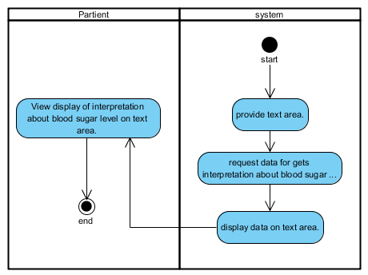

**Figure 27:** **AD: 26:** View interpretation of blood sugar.

|  |  |  |  |  |  |
| --- | --- | --- | --- | --- | --- |
| Use Case ID | UC27 | | | | |
| Use Case Name | Patient select food name from the database. | | | | |
| Created By | Jirayu Chinpongsuwan | | | Last Update By | Jirayu Chinpongsuwan |
| Date Created | 25/4/2016 | | | Last Revision Date | 25/4/2016 |
| Actors | Patient | | | | |
| Description | Patient can select food name eat in that day from the database. | | | | |
| Trigger | - Patient selects behavior monitor link button. | | | | |
| Preconditions | - Patient login to system. | | | | |
| Use Case Input Specification | | | | | |
| Input | type | Constraint | | | Example |
| - | - | - | | | - |
| Post conditions | - Patient select food success. | | | | |
| Normal Flows | User | | System | | |
|  | 2. Patient must select food.  3. Patient must click “select”. | | 1. The system shall provide drop down list of food. And provide “select” button.  4. The system shall provide text area to display food selected. | | |
| Alternative Flow | - | | | | |
| Exception Flow | - | | | | |
| Assumption | 1. Users understand English. 2. Users must be member of web application. | | | | |

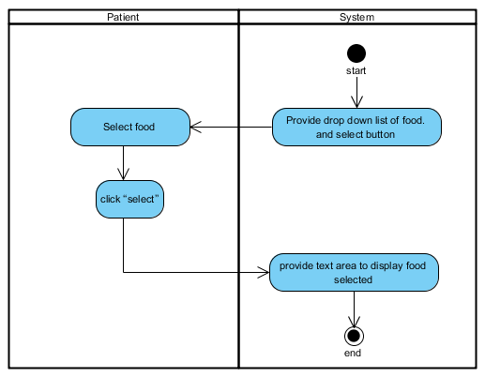

**Figure 28:** **AD: 27:** Patient select food name from the database.

|  |  |  |  |  |  |
| --- | --- | --- | --- | --- | --- |
| Use Case ID | UC28 | | | | |
| Use Case Name | Patient can check the list of medicine. | | | | |
| Created By | Jirayu Chinpongsuwan | | | Last Update By | Jirayu Chinpongsuwan |
| Date Created | 25/4/2016 | | | Last Revision Date | 25/4/2016 |
| Actors | Patient | | | | |
| Description | Patient can check the list of medicine on behavior monitor page. | | | | |
| Trigger | - Patient selects behavior monitor link button. | | | | |
| Preconditions | - Patient login to system. | | | | |
| Use Case Input Specification | | | | | |
| Input | type | Constraint | | | Example |
| - | - | - | | | - |
| Post conditions | - Patient check list medicine success. | | | | |
| Normal Flows | User | | System | | |
|  | 2. Patient must click “check button” follow list of medicine. | | 1. The system shall provide check button and list of medicine name to patient. | | |
| Alternative Flow | - | | | | |
| Exception Flow | - | | | | |
| Assumption | 1. Users understand English. 2. Users must be member of web application. | | | | |

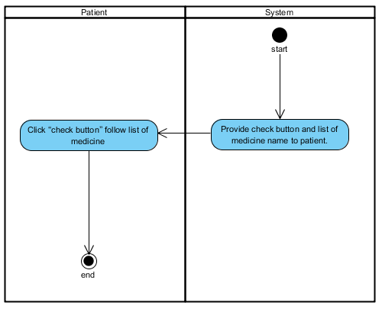

**Figure 29:** **AD: 28:** Patient can check the list of medicine.

|  |  |  |  |  |  |
| --- | --- | --- | --- | --- | --- |
| Use Case ID | UC29 | | | | |
| Use Case Name | Analyze. | | | | |
| Created By | Jirayu Chinpongsuwan | | | Last Update By | Jirayu Chinpongsuwan |
| Date Created | 25/4/2016 | | | Last Revision Date | 25/4/2016 |
| Actors | Patient | | | | |
| Description | Patient can get analyze of nutrition behavior in each day on behavior monitor page. | | | | |
| Trigger | - Patient selects behavior monitor link button. | | | | |
| Preconditions | - Patient login to system. | | | | |
| Use Case Input Specification | | | | | |
| Input | type | Constraint | | | Example |
| - | - | - | | | - |
| Post conditions | - Patient can get analyze of nutrition behavior from system. | | | | |
| Normal Flows | User | | System | | |
|  | 4. The patient get analyze result from the system. | | 1. The system shall provide UI to display analyze result  2. The system request data of food and medicine to analyze  3. The system display analyze result on UI (color red, color yellow, color green) | | |
| Alternative Flow | In normal flow step 3.   1. The system shall display analyze result green color, when the user gets glycemic index value less than 120 and check all list of medicine. 2. The system shall display analyze result yellow color, when the user gets glycemic index value more than 120 and check all list of medicine or get glycemic index value less than 120 and not check all list of medicine. 3. The system shall display analyze result red color, when the user gets glycemic index value more than 120 and not check all list of medicine. | | | | |
| Exception Flow | - | | | | |
| Assumption | 1. Users understand English. 2. Users must be member of web application. | | | | |

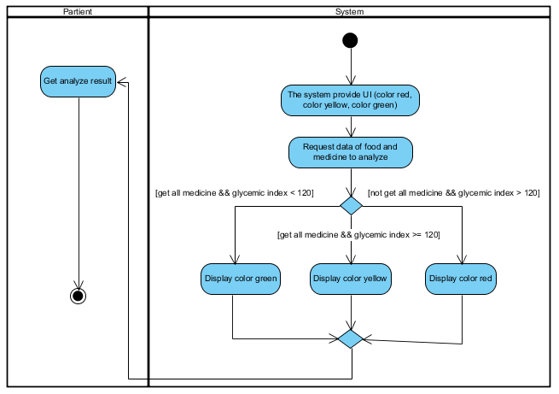

**Figure 30:** **AD: 29:** Analyze.

|  |  |  |  |  |  |
| --- | --- | --- | --- | --- | --- |
| Use Case ID | UC30 | | | | |
| Use Case Name | View the daily graph of glycemic level. | | | | |
| Created By | Jirayu Chinpongsuwan | | | Last Update By | Jirayu Chinpongsuwan |
| Date Created | 25/4/2016 | | | Last Revision Date | 25/4/2016 |
| Actors | Patient | | | | |
| Description | The patient can view the daily graph of glycemic level on behavior monitor page. | | | | |
| Trigger | - Patient selects behavior monitor link button. | | | | |
| Preconditions | - Patient login to system. | | | | |
| Use Case Input Specification | | | | | |
| Input | type | Constraint | | | Example |
| - | - | - | | | - |
| Post conditions | - Patient can view the daily graph of glycemic level. | | | | |
| Normal Flows | User | | System | | |
|  | 5. The patient view display graph. | | 1. The system shall provide line graph.  2. The system request data of glycemic index from food that selected in behavior monitor page  3. The system request the data of glycemic index to using on graph.  4. The system display line graph to patient. | | |
| Alternative Flow | - | | | | |
| Exception Flow | - | | | | |
| Assumption | 1. Users understand English. 2. Users must be member of web application. | | | | |

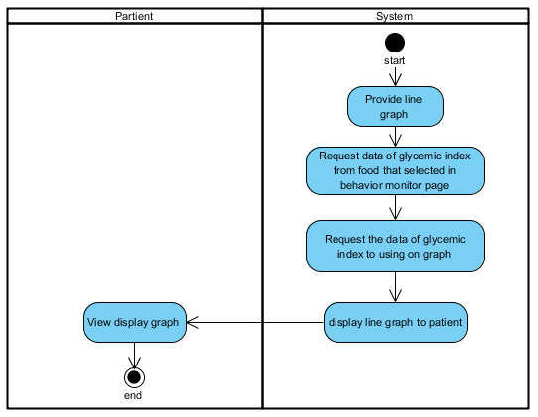

**Figure 31:** **AD: 30:** View the daily graph of glycemic level.